**Table of content**

I. Install Ruby, rails gem and devkit 2

*1.* *Install Ruby (Version: 2.1.5)* 2

*2.* *Update rubygems* 3

*3.* *Install rails by gem (Version 4.2.0)* 3

*4.* *Install devkit (Version 4.7.2)* 3

*5.* *Install capybara-webkit.* 5

II. Get Rails Application source code 12

III. Install MySQL (Version 5.6.19) 12

*1.* *Install mysql-installer-community-5.6.19.0.msi on server machine* 12

*2.* *Install MySQL-Front_Setup* 15

*3.* *Add path to workbench tools to PATH system variable* 16

IV. Create RAILS_ENV system variable 16

V. Create database 17

VI. Start Rails Application 17

VII. Configure email server 20

VIII. Configure IE for running script 20

**Deploy and Configure Rails Application on a machine**

* *Needed software is stored in* ***/System/4 - Project files/SQAAuto/software***
  + **FTP Server**: <ftp://192.168.191.151>
  + **Username**: [ftp.lgdn](ftp://ftp.lgdn)
  + **Password**: q9G*WvZbtEEw

# Install Ruby, rails gem and devkit

## *Install Ruby (Version: 2.1.5)*

Install **rubyinstaller-2.1.5.exe** file and follow steps to set up:

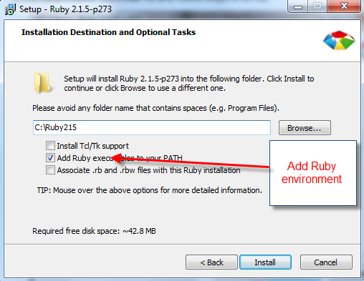

*Notes:*

* *After Ruby was installed successfully, make sure that CMD can recognize ruby statement by typing ‘ruby ‘or‘gem list’.*

*If not, you need to add Ruby environment path:*

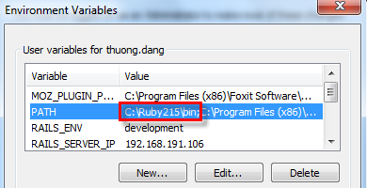

* *If you get an error when installing ruby lib by gem, likes this:*

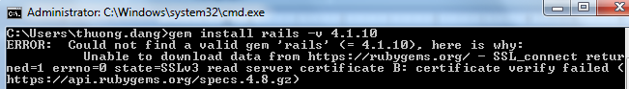

*Please copy* ***cacert.pem*** *from SQAAuto source code* ***/lib/assets*** *into {C:\Ruby215}\lib\ruby\2.1.0\rubygems\ssl_certs folder path.*

## *Update rubygems*

* Open cmd
* Type **‘gem update --system’**

## *Install rails by gem (Version 4.2.0)*

You are able to install rails by:

* Open cmd
* Type **‘gem install rails –v 4.2.0’**

## *Install devkit (Version 4.7.2)*

*Please make sure that the DevKit’s v*ersion corresponds to Ruby’s version (32bits or 64bits)

* + - *Copy ‘D*evKit-mingw64-32-4.7.2-20130224-1151-sfx.exe’file from server
    - Extract this file to **C:\DevKit** folder. If you open **C:\DevKit** folder, it looks like:

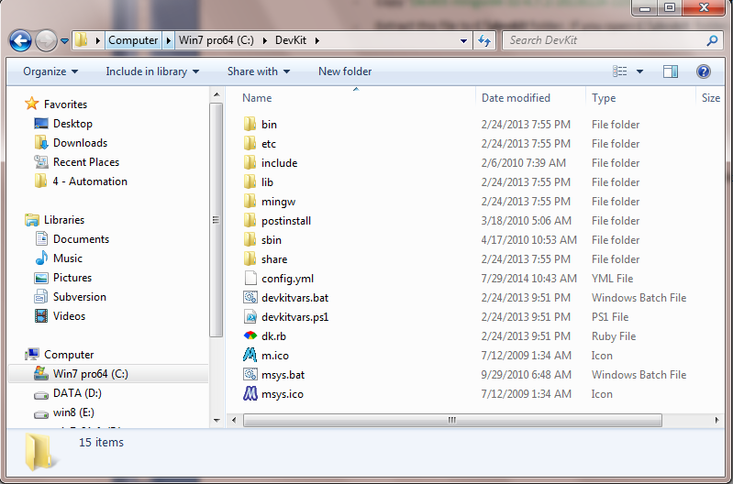

* Open CMD
* Cd to **C:\ DevKit**
* Type ***ruby dk.rb init***
* Type ***ruby dk.rb install***
* Add ***C:* DevKit*, C:* DevKit*\bin*** to system path environment like this:

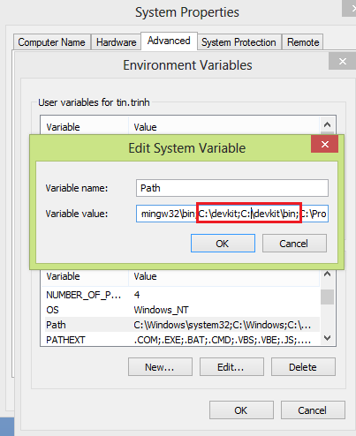

## *Install capybara-webkit.*

*Capybara-webkit aims running test scripts with webkit driver instead of selenium web driver*

**Software’s version:**

* rubyinstaller-2.1.5.exe
* DevKit-mingw64-32-4.7.2-20130224-1151-sfx.exe
* qt-opensource-windows-x86-mingw482-4.8.6-1.exe

**Steps:**

1. install ruby (refer to I.1)
2. install devkit (refer to I.3)
3. install QT
4. 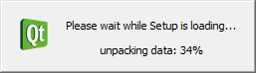
5. 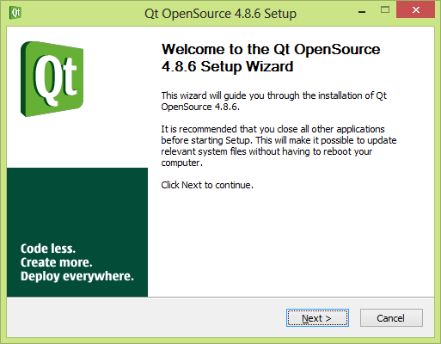
6. 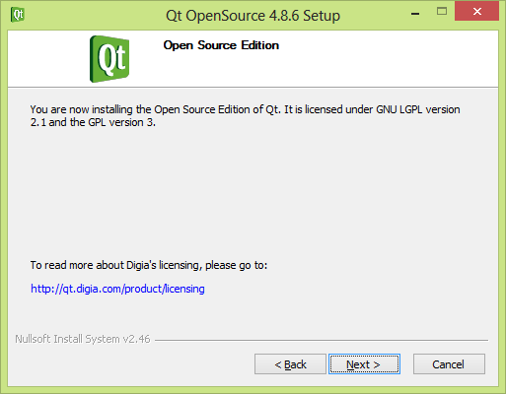
7. 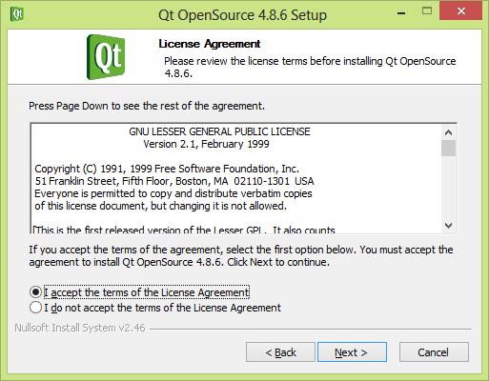
8. 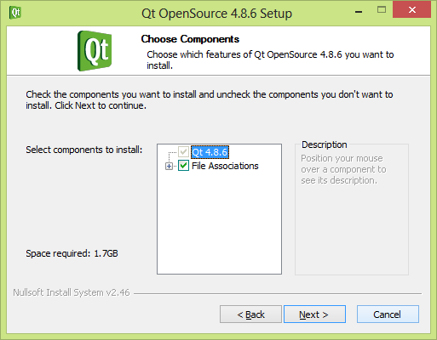
9. 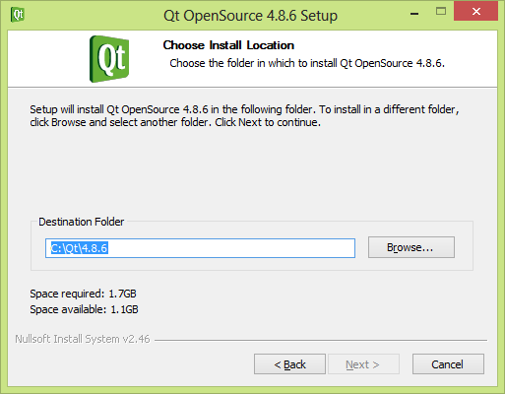
10. 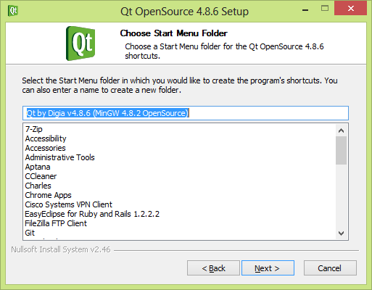
11. 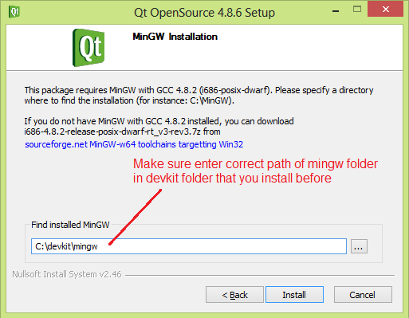
12. Install and add “C:\Qt\4.8.6\bin” to system path environment like this:

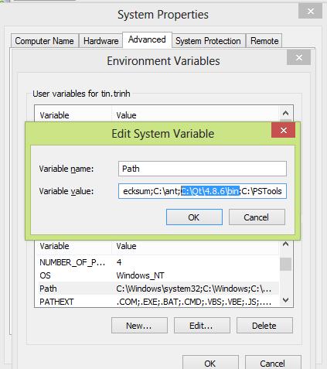

1. Edit content of “qmake.conf” file (C:\Qt\4.8.6\mkspecs\win32-g++):

Add “QMAKE_LFLAGS = -static-libgcc -static-libstdc++” into “qmake.conf” file

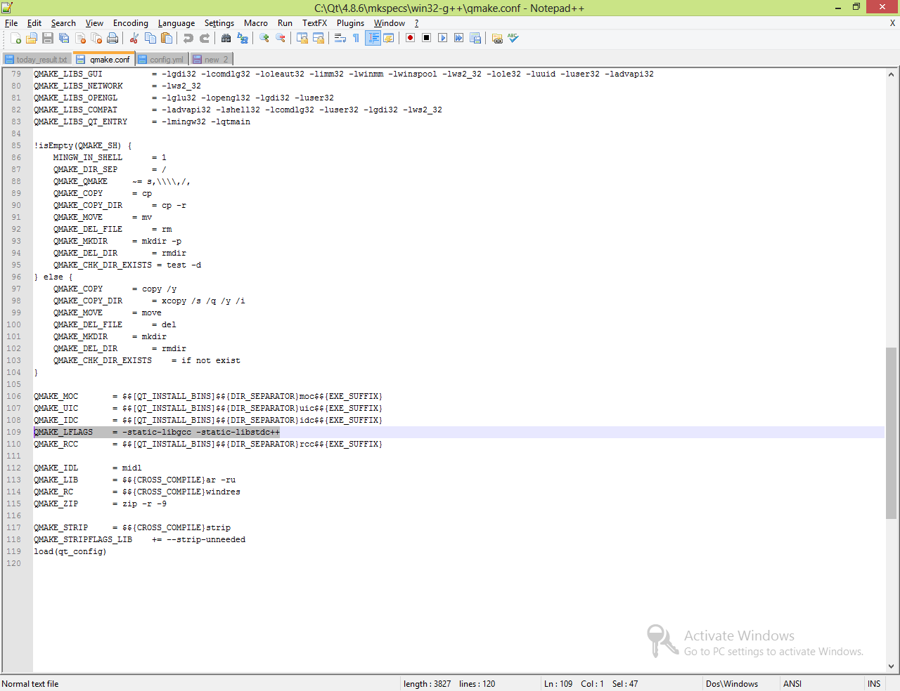

1. Make sure these variable values “C:\Ruby215\bin;C:\devkit;C:\devkit\bin;C:\Qt\4.8.6\bin;” are added into system path environment. One tip that these variable values should be added to system path only.

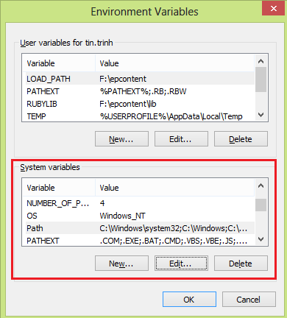

1. Install capybara-webkit using “gem install capybara-webkit” in command line.

# Get Rails Application source code

* + - Link to get source code:

<ssh://git@stash.leapfrog.com:7999/sqaa/sqaauto_testcentral.git>

# Install MySQL (Version 5.6.19)

## *Install mysql-installer-community-5.6.19.0.msi on server machine*

Follow the under steps to install MySQL installer community:

* + - Run **mysql-installer-community-5.6.19.0.msi** file

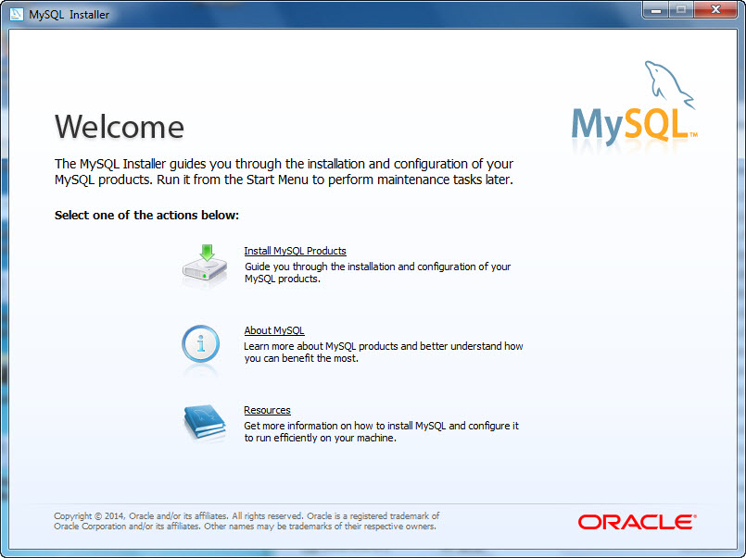

* + - Accept license terms
    - Find latest product

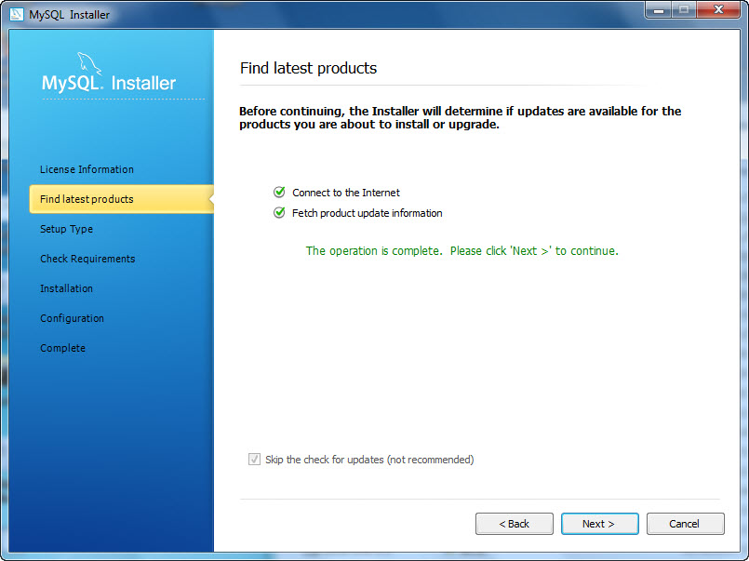

* + - Select Setup type (You should only select Server Only type)

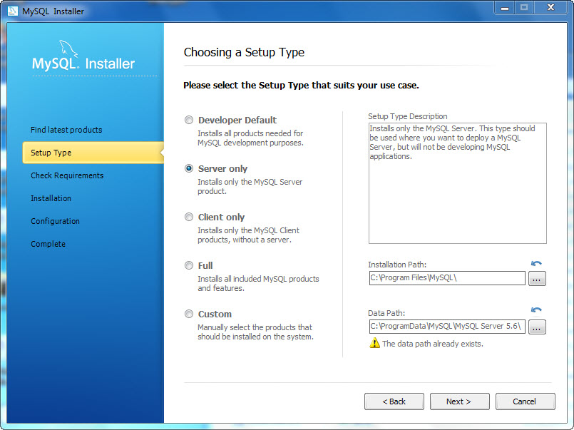

* + - **Follow steps to Configuration screen**

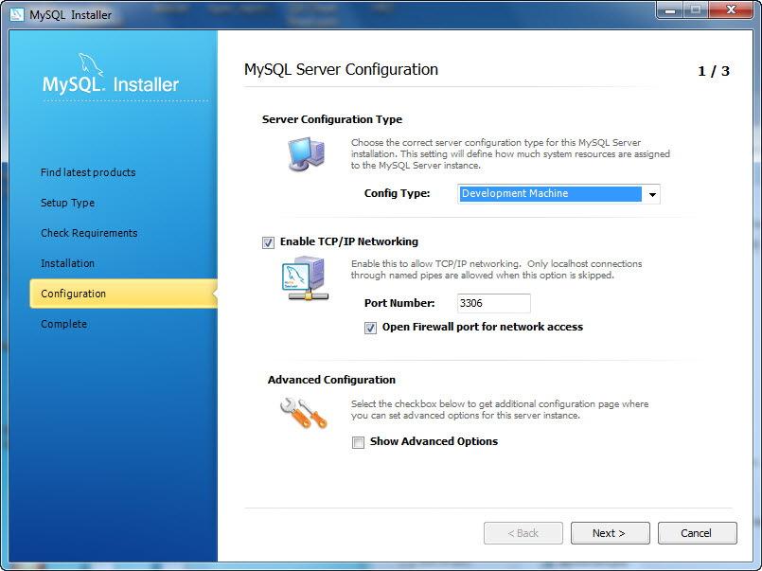

* + - Use root password from /sqaauto_testcentral/config/database.yml development config section.

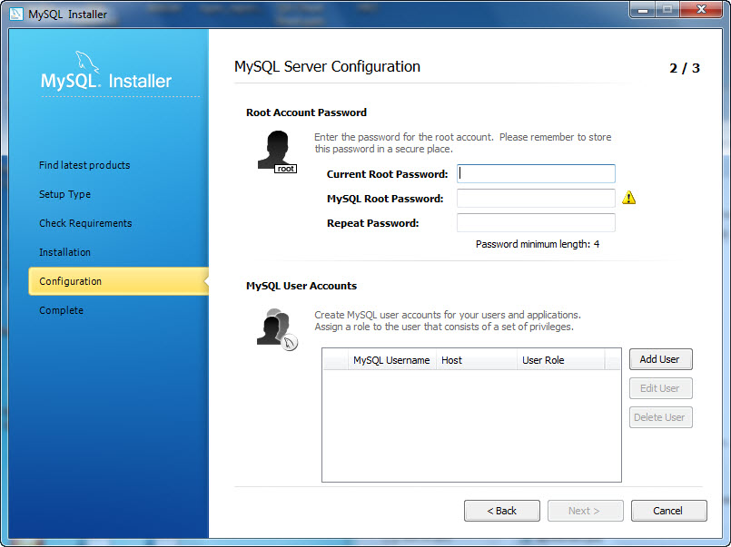

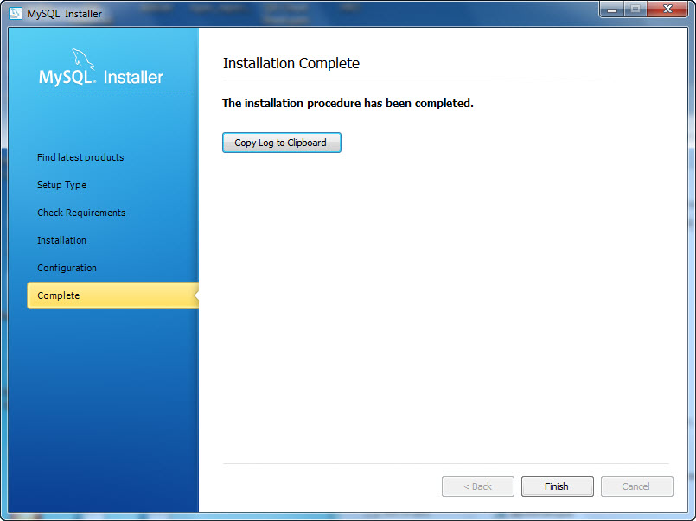

## *Install MySQL-Front_Setup*

* + - *Run MySQL-Front_Setup.exe file and follow steps to setup MySQL-Front*

*This software is used to manage MySQL database*

## *Add path to workbench tools to PATH system variable*

;C:\Program Files (x86)\MySQL\MySQL Workbench CE 6.1.6;

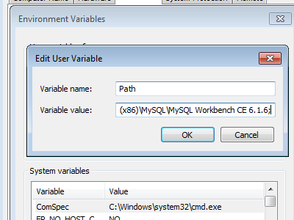

# Create RAILS_ENV system variable

Create the system variable

Variable name: RAILS_ENV

Variable value: development

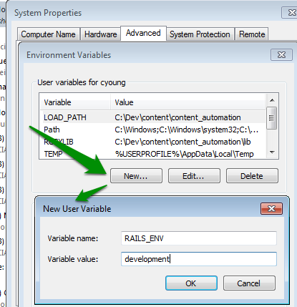

# Create database

* 1. Open CMD and cd to **/sqaauto_testcentral**
  2. Run **rake db:reset**

# Start Rails Application

* + - Open **/sqaauto_testcentral/config/database.yml** file and update MySQL Information section accordingly
    - Open CMD and cd to **/sqaauto_testcentral**
* Type **bundle install**
  + - *This command line will install all missing gems: json, rake, tzinfo…*
    - *If you get some error related to install json, rake... Please ensurethat version on Ruby and DevKitare the same and you are able to fix errors by following steps in command line.*

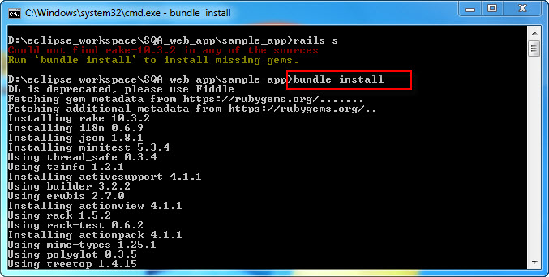

* Type**‘rails server’** or **‘rails s’**to start server

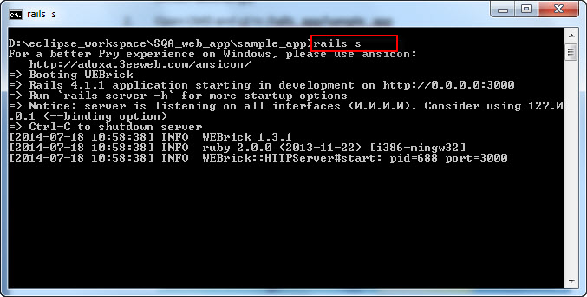

* + - Run Rails Application on browser

Navigate to the link**:** [**http://localhost:3000/**](http://localhost:3000/)or**http://{machine_ip_address}:3000/**

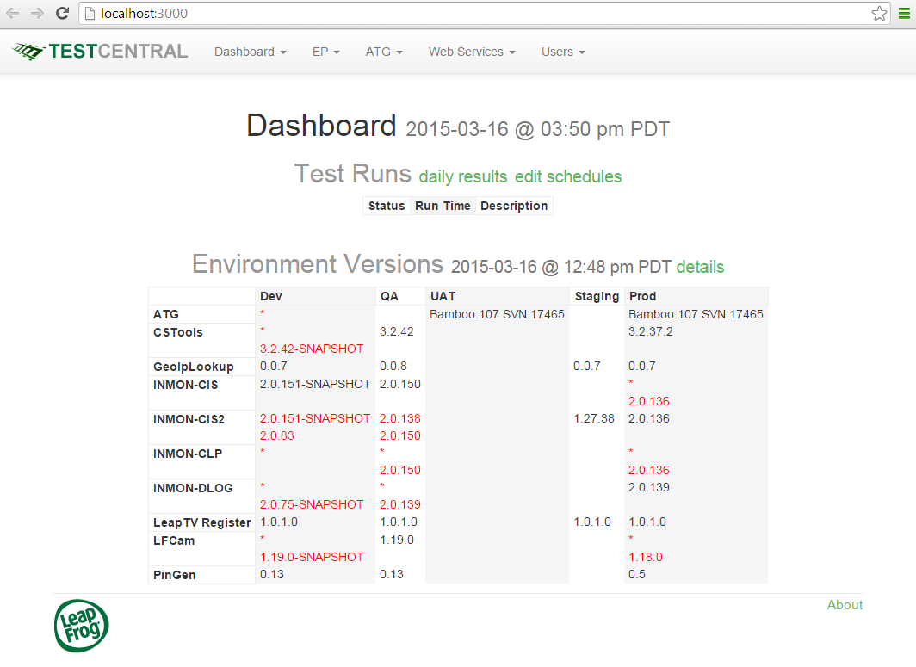

# Configure email server

You need to set up email server environment (dev or prod) before running script. To do that, open the **‘sqaauto_testcentral/config/config.xml’**and change the smtp settings accordingly.

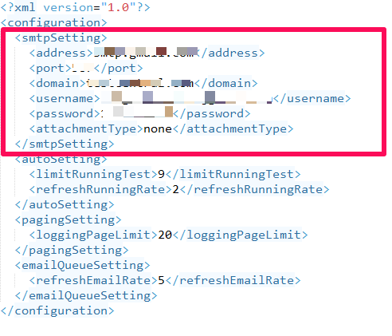

# Configure IE for running script

1. Require: IE 11 installed
2. Go to IE/Internet Option/Security Tab
3. Enable “Protected Mode” for all “Internet”, “Local Intranet”, “Trusted Site”, “Restricted sites”

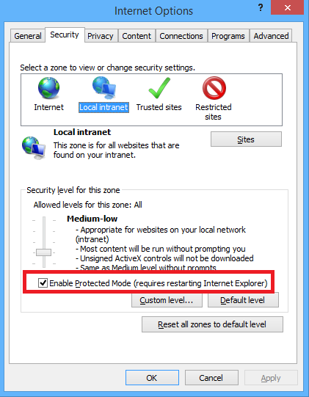

1. Go to Advance Tab
2. Disable “Enhanced Protected Mode” if it is enabled

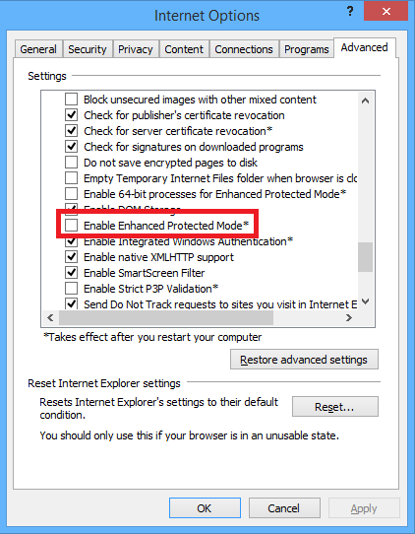

1. Set Zoom Level of IE to 100%

